Your contact partner:

Philipp Schulte-Derne
Marketing and Internet

Telephone +49 7022 702-129
Fax +49 7022 702-101
Philipp.schulte-derne@holzher.com
Total number of words: 785
Characters (including spaces): 4837

February 2017

Date

PRESS RELEASE

Perfect solutions right from the start –
The smart workshop for modern furniture production
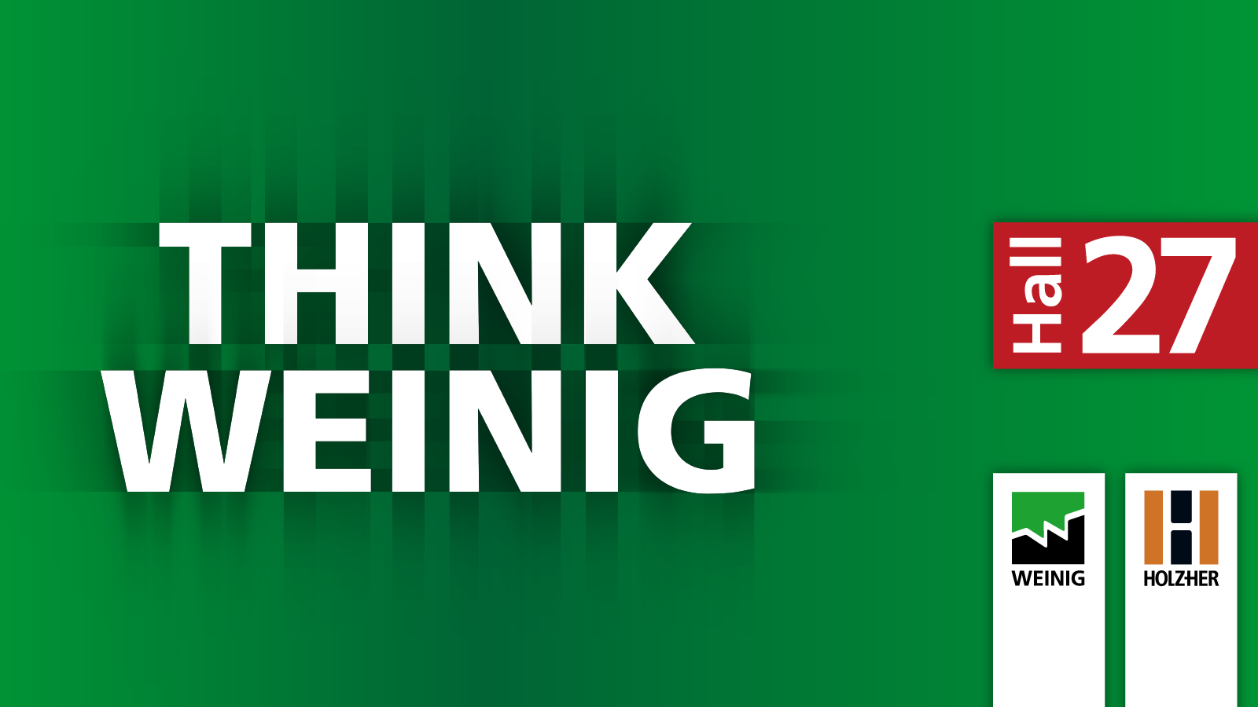
Very much in the spirit of the “THINK WEINIG” strategy, HOLZ-HER GmbH is presenting itself for the first time at LIGNA 2017, along with the Weinig Group in Hall 27. This means that a complete range of machining for both solid wood and derived timber products will be presented to the broad specialist audience on the stand of around 4,000 m² . In the area of machining for derived timber products, trade fair visitors can not only find out about machinery using modern production techniques for wood machining, but in fact also experience for themselves what the advantages of a smart workshop means in furniture production.

The new industry for ACCURA / LUMINA:
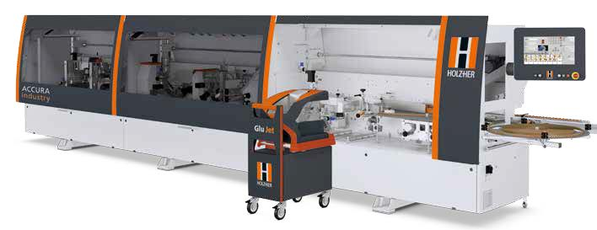
The new ACCURA and LUMINA Industry machines are equipped with the new Glu Jet PUR 2K for use with 2 kg PUR glue sticks on the newly-developed changing station. High-quality furniture production starts with selection of the right machine. “ACCURAte”, professional edgebanding with no compromises, that is the benchmark of this new series. As an ACCURA Industry version, in addition to fully automatic operation, the machine also offers the Glu Jet PUR 2K glue station as standard, which enables the processing of large 2 kg glue sticks that are available commercially from all leading glue manufacturers. The new glue station is designed as a changing station based on technology from the LUMINA series with HSK adapter. The station can therefore easily be removed via a change-over carriage, which makes cleaning the glue application nozzle even easier. In addition, further Glu Jet stations can also
be exchanged on the same machine and even combined with
LTRONIC on the LUMINA Industry version to activate laser
edging. With the Glu Jet PUR 2K, users can process 2 kg PUR glue cartridges, which are significantly more economical than conventional PUR granules. The investment is worthwhile for customers who exclusively process PUR glues. With average usage in this area, the saving in terms of glue purchasing is at least 50 percent.

The new vertical SECTOR 1255 and 1260:
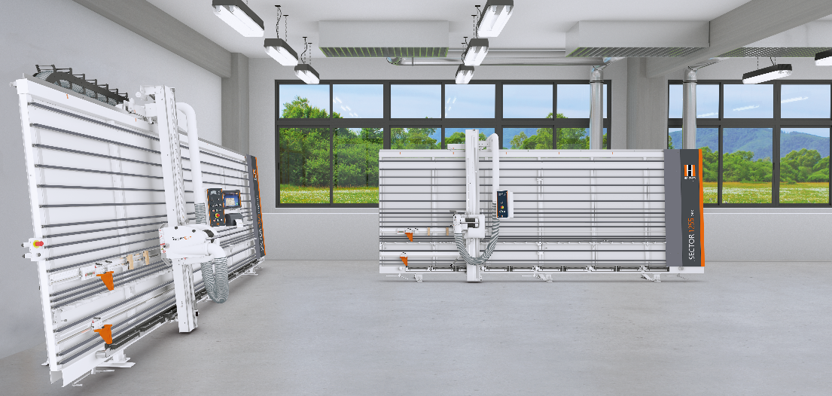
The new vertical panel saws from HOLZ-HER combine proven technology based on over 50 years of experience with a basic, solid design. Professional cutting technology could not be more space-saving. With a footprint from as little as 5 m², this vertical panel saw is unbeatable in this area and saves you the cost of additional space. The SECTOR 1255 pro and the automatic model, the SECTOR 1260 automatic, are available with cutting lengths of 3,300 to 6,300. The cutting heights are between 1,900 mm and 2,200 mm, depending on requirements. Their cutting depth is up to 60 mm. The horizontal cut is set via a digital display with electrical micro-adjustment of measurement, which is included as standard. The sawing unit has automatic interface detection which means it can be automatically engaged at the touch of a button - a unique feature in this saw class. A pneumatic shift grate prevents sawing into the support strips, moving the support grate automatically, as required. The automatic version of the SECTOR 1260 is also available, offering you even more efficient handling. In addition to all the features on the manual SECTOR 1255 machine, the SECTOR 1260 automatic can also automatically plunge cut, saw, retract and return to the operator at the touch of a button.

CNC nesting – the other way to saw: 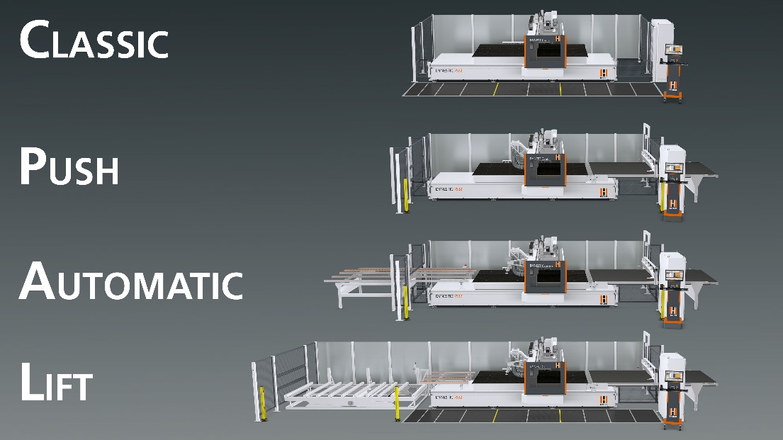
In Hall 27 at this year’s LIGNA, HOLZ-HER is showing what modern nesting technology has in common with high-precision gantry design. With the new DYNESTIC 7505, 7507 and 7532 gantry CNC machines, HOLZ-HER is moving the frontiers of nesting technology to completely new dimensions. Solid machine construction and technology at the highest level ensure high production capacity and precisely produced workpieces. In addition to the individual machine in the “classic” design, the new DYNESTIC models also fit into different automation environments very well. The “push” version pushes the finished nest onto the conveyor belt and cleans the machine table for the next machining process. The “automatic” version is ideal for high performance - even for lot sizes of 1 - in combination with the automatic HOLZ-HER STORE-MASTER 5110 panel handling system and the DYNESTIC 7532 lift and standard elevating table enable highly efficient machining of complete stacks of panels.

Cabinets on CNC machines without any programming – is that possible?
Yes, that will be possible in future at HOLZ-HER with the new NEXTEC models. Derived from “Next Technology”, users can produce furniture even more easily and quickly with this new nesting technology – and all this without programming. Experience the new NEXTEC for yourself at LIGNA. Select – position – ready - that’s the way to build furniture today!

