Your contact partner:

**Philipp Schulte-Derne**

Marketing and Communication

Telephone +49 7022 702-129

Fax +49 7022 702-101

Philipp.schulte-derne@holzher.com

Total number of words: 830

Characters (including spaces): 6678

**Januar 2020**

#### Date

PRESS RELEASE

**The Weinig Group at the Holz-Handwerk *[Trade Fair for Woodworking Machines]* / Fensterbau frontale 2020: Numerous world premieres to inspire visitors**

At the **Holz-Handwerk / Fensterbau frontale 2020** in Nürnberg, the Weinig Group's exhibition line includes over 25 exhibits, representing pioneering technologies for maximum customer benefit. At the exhibition the brands **Weinig** and **HOLZ-HER** will present a variety of world firsts for processing solid wood as well as derived timber products. "Craftsmanship" and the solutions offered by the **Weinig Group** form a partnership for long-term success and sustainability. This is the experience offered to visitors at our group exhibition booth with total floor space of over **1600 m²**.

**Vertical CNC machining with our "best performers", the EVOLUTION 7402 and 7405 Connect:**

The Evolution models offer complete, versatile and universal machining on all 4 edges with their completely new design revealed for the first time at the Holz-Handwerk 2020. As one of Holz-Her's best performers, this machine series now incorporates state-of-the-art machine design to align perfectly with Holz-Her's world of products.

In addition to four-sided workpiece formatting, the Evolution 7402 4mat offers entirely new processing capabilities with its new, optional tool changer for up to four tools. Cutouts, engraving, profiling and machining for furniture connectors are just a few examples, making these vertical CNC machines absolute all-rounders with minimum space requirements. For changing tools, the fully equipped **Evolution 7402** has a powerful 7.5 kW spindle and drilling head including grooving saw.

The **xcut package** for the Evolution models will be presented live for the first time at the Trade Fair for Woodworking Machines. With this package the vertical CNC machines automatically produce the required workpieces from panel strips previously cut in the longitudinal direction. This xcut mode completely eliminates cross-cuts otherwise required. The intuitive software for the xcut mode lists all jobs pending on the machine. This provides the machine operator with a perfect overview of all jobs and the required strip material. In interaction with the edgebander, the two machines form an efficient production cell to optimize operating sequences in combination.

With the "connect" and "doors" models of the **Evolution 7405** 4mat, HOLZ-HER has gone a step further. The optional "doors" package consists of a specially developed angle gear for lock cases and a lock case milling tool to allow complete processing of door leaves with a maximum thickness of up to 70 mm. The optional "connect" package allow various connection technologies to be processed on the Evolution 7405 4mat. For example milling pockets for Lamello Clamex or OVVO connectors in one clamping operation. Naturally, you can cut pockets for these - as well as other - connectors on all four edges as well as in the X and Y directions. For this purpose HOLZ-HER has supplemented the Evolution to include an additional seventh tool changer location as well as a newly developed attachment and the matching programming macro.

**The perfect nesting cell - NEXTEC 7735 and Store Master panel storage system.**

The NEXTEC 7735 offers a unique combination of maximum flexibility and extremely simple operation! Equipped with a 5-axis milling spindle and 2,200 mm deep grid table, the 7735 offers virtually unlimited machining possibilities. All features of the NEXTEC series, such as the CabinetSelect Software for custom furniture without programming, are also used on the NEXTEC 7735. Naturally, the software package provided supports installation of all standard commercial nesting connectors requiring vertical machining only. The solution for the P system connectors from Lamello is unique, reliable and unbeatably fast. The optional NEXTEC Clamex package enables the milling of connector pockets into the panel surface in X and in Y directions. The intelligent BetterNest software, along with a tool specially developed for it, also allow the milling of perfectly positioned Clamex pockets in the edges of the furniture parts, before these are formatted for size in the same clamping operation. And, thanks to the 5-axis technology, this is easy to do even in miters! This is the way to master all connections with ease on the NEXTEC.

In combination with a Store Master panel storage unit, this system increases efficiency enormously. Simultaneously it minimizes handling and the panel material is supplied gently just-in-time to the HOLZ-HER nesting CNC machine or pressure beam saw.

**Power packages from the family of pressure beam saws**

The family of pressure beam saws features the Tectra 6120 and Zentrex 6215 with the highly stable machine architecture for which HOLZ-HER is famous. The absolute highlight is the 2-stage evacuation management system. Cutting-plan-controlled evacuation flaps in the pressure beam, which open or close depending on the length of the cut, increase the evacuation capacity at the saw blade, ensuring a clean machine table. With scratch cuts, a controlled, moving evacuation hood behind the saw blade catches chips and dust flying away to the rear during the cutting operation. For panel sizes which are difficult to differentiate in terms of length or width in spite of 3D simulation on the screen, HOLZ-HER offers a laser positioning system with accuracy down to the last millimeter, making remeasuring panels or incorrect positioning on the machine a thing of the past.

**High-tech edgebanding - multi-function milling technology - affordable high efficiency**

Various radiuses or applications with 45° bezel can be machined at the touch of a button with the HOLZ-HER multi-models, Sprint 1327 multi, 1329 multi and Lumina 1380 multi. This reduces setup times enormously and allows

small lots to be run at any time.

Tedious setup operations on the edgebander can be eliminated with fa.s.t. “fa.s.t.” enables different machining processes to be run simultaneously on the edgebander. For example, it is possible for the operator to switch on the corner rounding unit without having to empty the machine for the set-up procedure. High speed NC servo-axes make this process extremely efficient, allowing full utilization of all capacities.

**Automation Pro**

Automation Pro networks the entire production sequence covering all HOLZ-HER machines from STORE MASTER panel storage to finished furniture even in large interior finishing plants and industrial production facilities. A suitable, preinstalled solution determines the production sequence. The HOLZ-HER Warehouse program plays a key role in this procedure. Released orders are transferred to this system, where they are managed and distributed to the required HOLZ-HER machines such as saws, nesting machines or edgebanders. New HOLZ-HER machines can of course be integrated as well.

Attachments:

1. New design for Evolution series

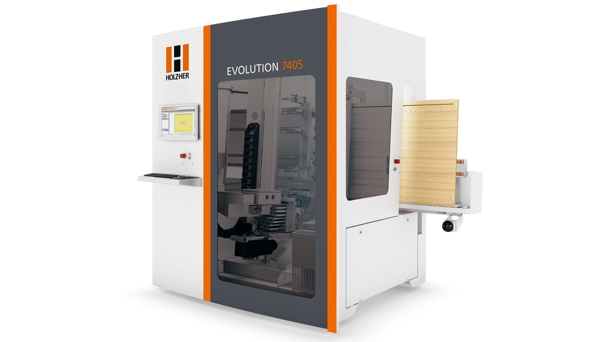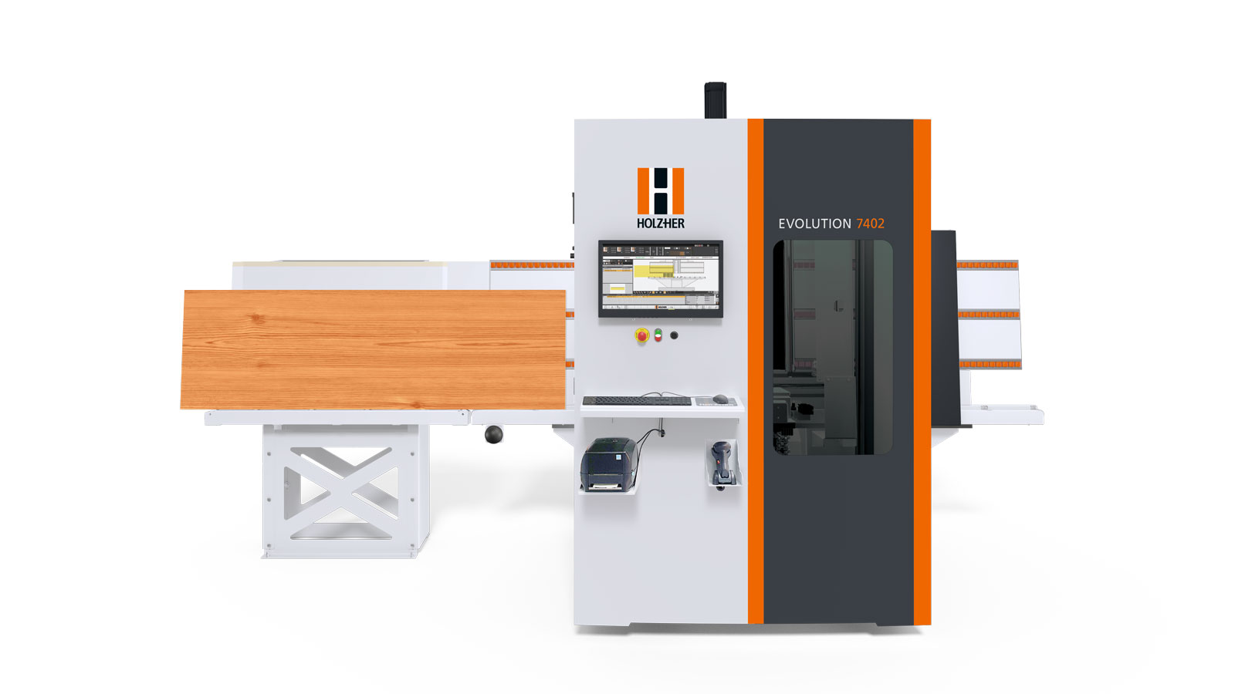

1. NEXTEC 7735 – the universal CNC machining center

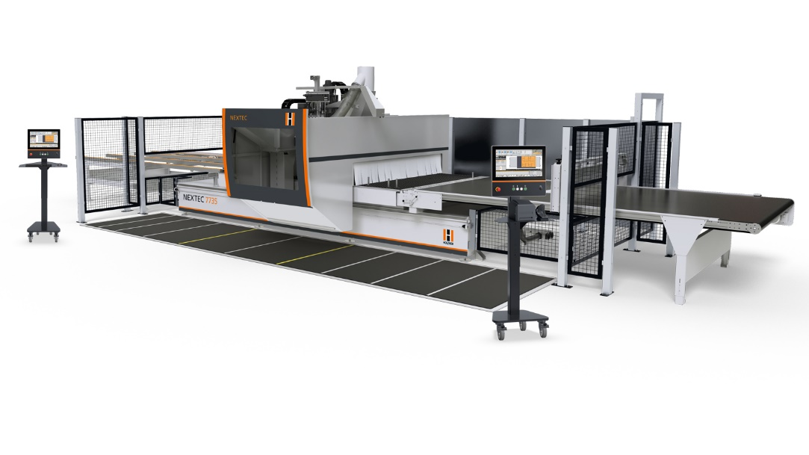

1. HOLZ-HER pressure beam saw for full cutting competency.

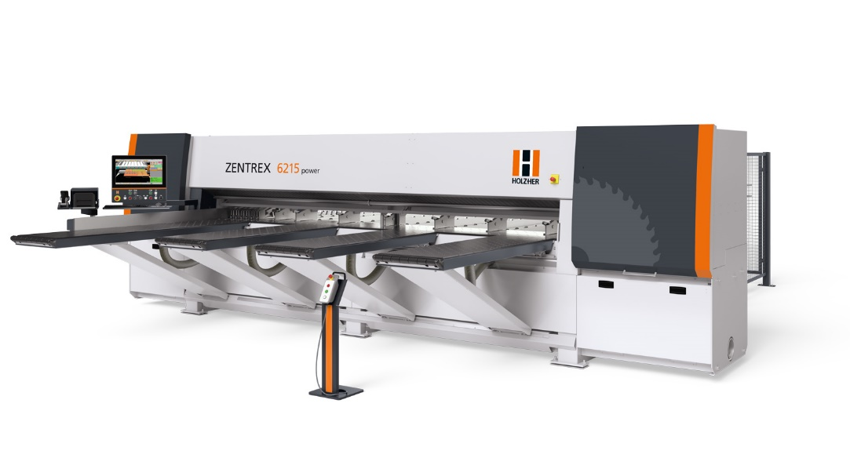

1. The all-inclusive, high-end solution for professional edgebanding.

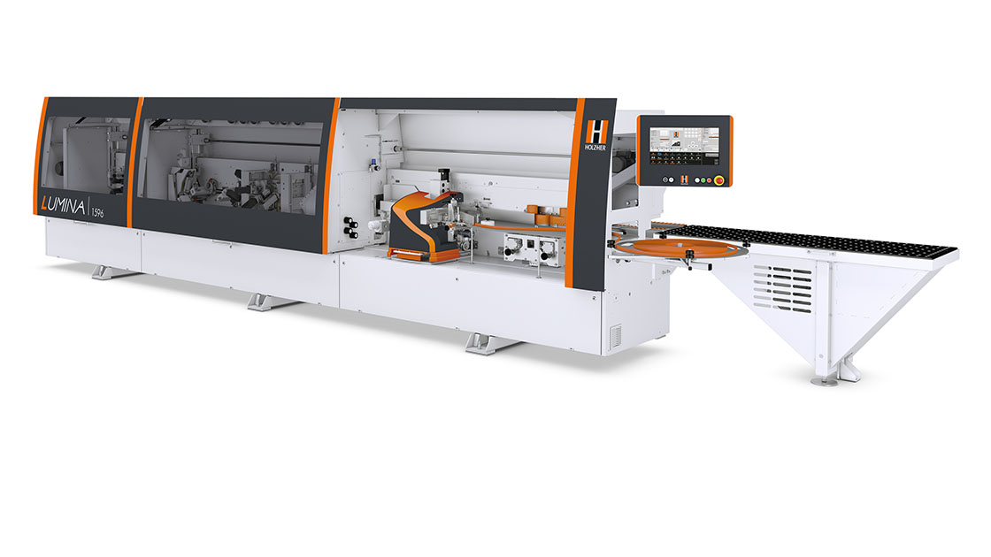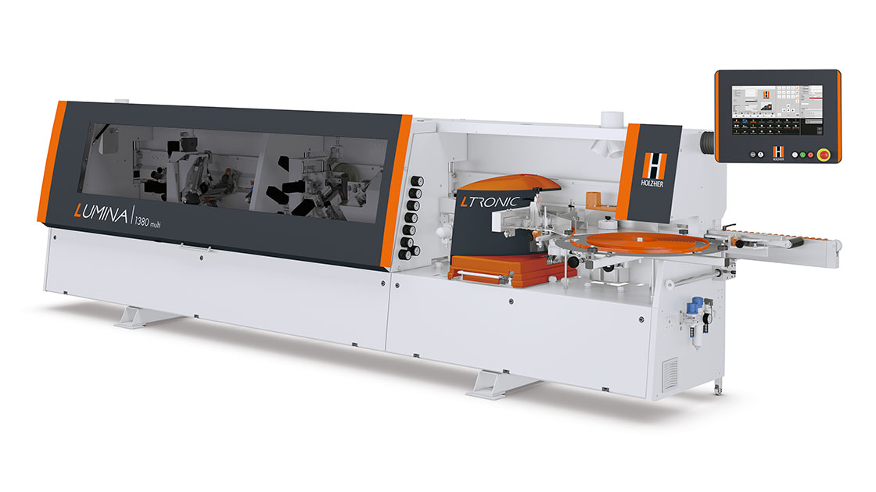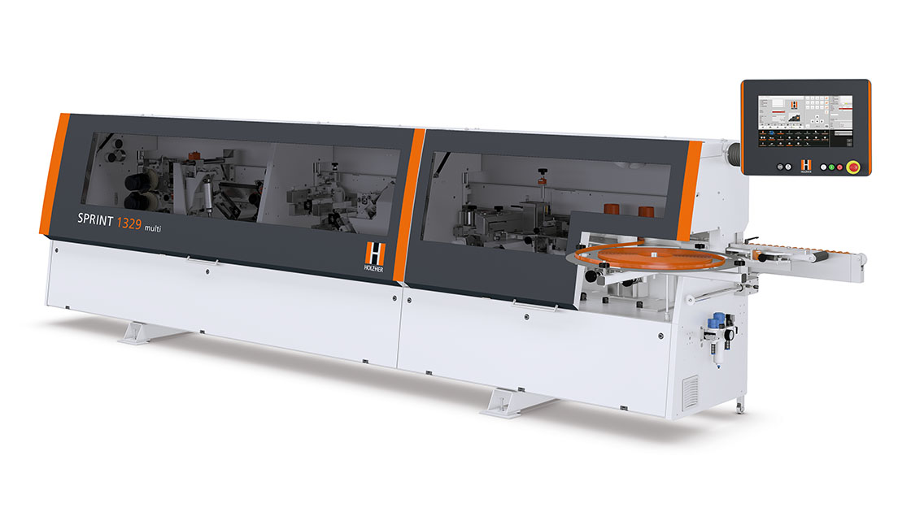

1. Automation Pro - the new dimension in  
   machine networking

